 | Department of Computer Science  Faculty of Computing

Project Task 5
(IP Addressing)

Programme | : | Bachelor of Computer Science (Data Engineering)
Subject Code | : | SECR1213
Subject Name | : | Network Communications
Session-Sem | : | 2024/2025-1

Prepared by | : |  | 1)Chau Ying Jia  2)Poh Lok Yee  3)Sabrina Heng Wei Qi  4)Woo Cheng Shuan | (A22CS0213)  (A23CS0262)  (A23CS0265)  (A23CS0283)
Section | : |  | 12
Group | : |  | 12.3 – 4Fabs
Lecturer | : |  | Mr. Firoz Bin Yusuf Patel Dawoodi

Table of Contents
5.1 Network address given 3
5.2 Divide it in the best possible way for network. 4
Meeting Minutes #9 17

5.1 Network address given
Group | Network Address
12.3 | 192.164.0.0/8

The given network address of our group is 192.164.0.0/8. It provides over 16 million IPs (2^24) which making it suitable for large-scale networks with thousands of devices. This ensures future scalability for massive expansion.

Network Address details:
IP address (decimal) | 192.164.0.0
IP address (binary) | 11000000 10100100 00000000 00000000
Subnet mask (decimal) | 255.0.0.0
Subnet Mask (binary) | 11111111 00000000 00000000 00000000

We divided the subnet mask into the network portion (8 bits) and host portion (24 bits). By using the AND operation of the IP address with the subnet mask, we identified the following:
Network Address | 192.164.0.0
Broadcast Address | 192.164.255.255
Range of Usable Addresses | 192.164.0.1 – 192.255.255.254

5.2 Divide it in the best possible way for network.
By using the Classless Inter-Domain Routing (CIDR) method, we decided to distribute the network into a different subnet for each work area defined in task 4 except for server room and staff office are using the same subnet. Thus, the network of our building needs to have an amount of 8 subnets in total.
Theoretically, 4 extra bits (2^4=16) could provide enough subnets, but this division would waste many IP addresses because of the size of each subnet that are better sized for our needs, we borrowed 5 bits from the host portion of the IP address which provides 2^5=32 possible subnets. This ensures the subnets are smaller and more efficient, while still leaving room for future scalability.
By borrowing 5 bits, the subnet mask changes form /8 to /13.
Network Portion = Original 8 bits + 5 borrowed subnet bits = 13 bits
Host Portion = Total 32 bits – 13 Network Portion bits = 19 bits
Divide subnet to 8 subnets:
Subnet Network | Network portion | Subnet bits | Host portion |  | IP address
0 | 1100 0000 | 1010 0 | 100  0000 0000  0000 0000 | Network  Address | 192.164.0.0
 |  |  | 111  1111 1111  1111 1111 | Broadcast  Address | 192.167.255.255
1 | 1100 0000 | 1010 1 | 000  0000 0000  0000 0000 | Network  Address | 192.168.0.0
 |  |  | 111  1111 1111  1111 1111 | Broadcast  Address | 192.175.255.255
2 | 1100 0000 | 1101 0 | 000  0000 0000  0000 0000 | Network  Address | 192.176.0.0
 |  |  | 111  1111 1111  1111 1111 | Broadcast  Address | 192.215.255.255
3 | 1100 0000 | 1101 1 | 000  0000 0000  0000 0000 | Network  Address | 192.216.0.0
 |  |  | 111  1111 1111  1111 1111 | Broadcast  Address | 192.223.255.255
4 | 1100 0000 | 1110 0 | 000  0000 0000  0000 0000 | Network  Address | 192.224.0.0
 |  |  | 111  1111 1111  1111 1111 | Broadcast  Address | 192.231.255.255
5 | 1100 0000 | 1110 1 | 000  0000 0000  0000 0000 | Network  Address | 192.232.0.0
 |  |  | 111  1111 1111  1111 1111 | Broadcast  Address | 192.239.255.255
6 | 1100 0000 | 11110 | 000  0000 0000  0000 0000 | Network  Address | 192.240.0.0
 |  |  | 111  1111 1111  1111 1111 | Broadcast  Address | 192.247.255.255
7 | 1100 0000 | 11111 | 000  0000 0000  0000 0000 | Network  Address | 192.248.0.0
 |  |  | 111  1111 1111  1111 1111 | Broadcast  Address | 192.255.255.255

Distribution of subnet for different work area:
Subnet | Work Area | Network Address | Broadcast Address | Range of usable address | Custom subnet mask
0 | Server Room and Staff Office | 192.164.0.0 | 192.167.255.255 | 192.164.0.1 - 192.167.255.254 | /13  255.248.0.0
Ground Floor
1 | General Lab 1 | 192.168.0.0 | 192.175.255.255 | 192.168.0.1 - 192.175.255.254 | /13  255.248.0.0
2 | General Lab 2 | 192.176.0.0 | 192.215.255.255 | 192.176.0.1 - 192.215.255.254 | /13  255.248.0.0
3 | Cisco Networking Lab | 192.216.0.0 | 192.223.255.255 | 192.216.0.1 - 192.223.255.254 | /13  255.248.0.0
4 | Embedded Lab | 192.224.0.0 | 192.231.255.255 | 192.224.0.1 - 192.231.255.254 | /13  255.248.0.0
First Floor
5 | Hybrid Classroom | 192.232.0.0 | 192.239.255.255 | 192.232.0.1 - 192.239.255.254 | /13  255.248.0.0
6 | Student Lounge | 192.240.0.0 | 192.247.255.255 | 192.240.0.1 - 192.247.255.254 | /13  255.248.0.0
7 | Video Conferencing Room | 192.248.0.0 | 192.255.255.255 | 192.248.0.1 - 192.255.255.254 | /13  255.248.0.0
Network distribution for workstation in different work areas.
Ground Floor:
- General Lab 1
Device | IP Address
PC1 | 192.168.0.1
PC2 | 192.168.0.2
PC3 | 192.168.0.3
PC4 | 192.168.0.4
PC5 | 192.168.0.5
PC6 | 192.168.0.6
PC7 | 192.168.0.7
PC8 | 192.168.0.8
PC9 | 192.168.0.9
PC10 | 192.168.0.10
PC11 | 192.168.0.11
PC12 | 192.168.0.12
PC13 | 192.168.0.13
PC14 | 192.168.0.14
PC15 | 192.168.0.15
PC16 | 192.168.0.16
PC17 | 192. 168.0.17
PC18 | 192. 168.0.18
PC19 | 192. 168.0.19
PC20 | 192. 168.0.20
PC21 | 192. 168.0.21
PC22 | 192. 168.0.22
PC23 | 192. 168.0.23
PC24 | 192. 168.0.24
PC25 | 192. 168.0.25
PC26 | 192. 168.0.26
PC27 | 192. 168.0.27
PC28 | 192. 168.0.28
PC29 | 192. 168.0.29
PC30 | 192. 168.0.30
PC31 | 192. 168.0.31
Projector 1 | 192. 168.0.32
WAP 1 | 192. 168.0.33
WAP 2 | 192. 168.0.34

- General Lab 2
Device | IP Address
PC32 | 192.176.0.1
PC33 | 192.176.0.2
PC34 | 192.176.0.3
PC35 | 192.176.0.4
PC36 | 192.176.0.5
PC37 | 192.176.0.6
PC38 | 192.176.0.7
PC36 | 192.176.0.8
PC40 | 192.176.0.9
PC41 | 192.176.0.10
PC42 | 192.176.0.11
PC43 | 192.176.0.12
PC44 | 192.176.0.13
PC45 | 192.176.0.14
PC46 | 192.176.0.15
PC47 | 192.176.0.16
PC48 | 192.176.0.17
PC49 | 192.176.0.18
PC50 | 192.176.0.19
PC51 | 192.176.0.20
PC52 | 192.176.0.21
PC53 | 192.176.0.22
PC54 | 192.176.0.23
PC55 | 192.176.0.24
PC56 | 192.176.0.25
PC57 | 192.176.0.26
PC58 | 192.176.0.27
PC59 | 192.176.0.28
PC60 | 192.176.0.29
PC61 | 192.176.0.30
PC62 | 192.176.0.31
Projector 2 | 192.176.0.32
WAP 3 | 192.176.0.33

- Cisco Networking Lab
Device | IP Address
PC63 | 192.216.0.1
PC64 | 192.216.0.2
PC65 | 192.216.0.3
PC66 | 192.216.0.4
PC67 | 192.216.0.5
PC68 | 192.216.0.6
PC69 | 192.216.0.7
PC70 | 192.216.0.8
PC71 | 192.216.0.9
PC72 | 192.216.0.10
PC73 | 192.216.0.11
PC74 | 192.216.0.12
PC75 | 192.216.0.13
PC76 | 192.216.0.14
PC77 | 192.216.0.15
PC78 | 192.216.0.16
PC79 | 192.216.0.17
PC80 | 192.216.0.18
PC81 | 192.216.0.19
PC82 | 192.216.0.20
PC83 | 192.216.0.21
PC84 | 192.216.0.22
PC85 | 192.216.0.23
PC86 | 192.216.0.24
PC87 | 192.216.0.25
PC88 | 192.216.0.26
PC89 | 192.216.0.27
PC90 | 192.216.0.28
PC91 | 192.216.0.29
PC92 | 192.216.0.30
Projector 3 | 192.216.0.31
WAP 4 | 192.216.0.32

- Embedded Lab
Device | IP Address
PC93 | 192.224.0.1
PC94 | 192.224.0.2
PC95 | 192.224.0.3
PC96 | 192.224.0.4
PC97 | 192.224.0.5
PC98 | 192.224.0.6
PC99 | 192.224.0.7
PC100 | 192.224.0.8
PC101 | 192.224.0.9
PC102 | 192.224.0.10
PC103 | 192.224.0.11
PC104 | 192.224.0.12
PC105 | 192.224.0.13
PC106 | 192.224.0.14
PC107 | 192.224.0.15
PC108 | 192.224.0.16
PC109 | 192.224.0.17
PC110 | 192.224.0.18
PC111 | 192.224.0.19
PC112 | 192.224.0.20
PC113 | 192.224.0.21
PC114 | 192.224.0.22
PC115 | 192.224.0.23
PC116 | 192.224.0.24
PC117 | 192.224.0.25
PC118 | 192.224.0.26
PC119 | 192.224.0.27
PC120 | 192.224.0.28
PC121 | 192.224.0.29
PC122 | 192.224.0.30
PC123 | 192.224.0.31
Projector 4 | 192.224.0.32
WAP 5 | 192.224.0.33

Ground floor with label:
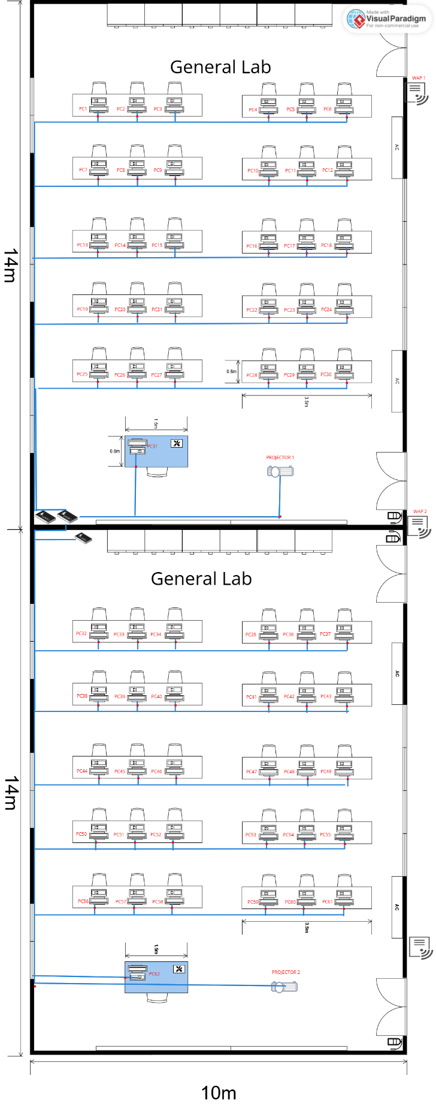
Figure 5.2.1 General Lab 1 & 2 with label

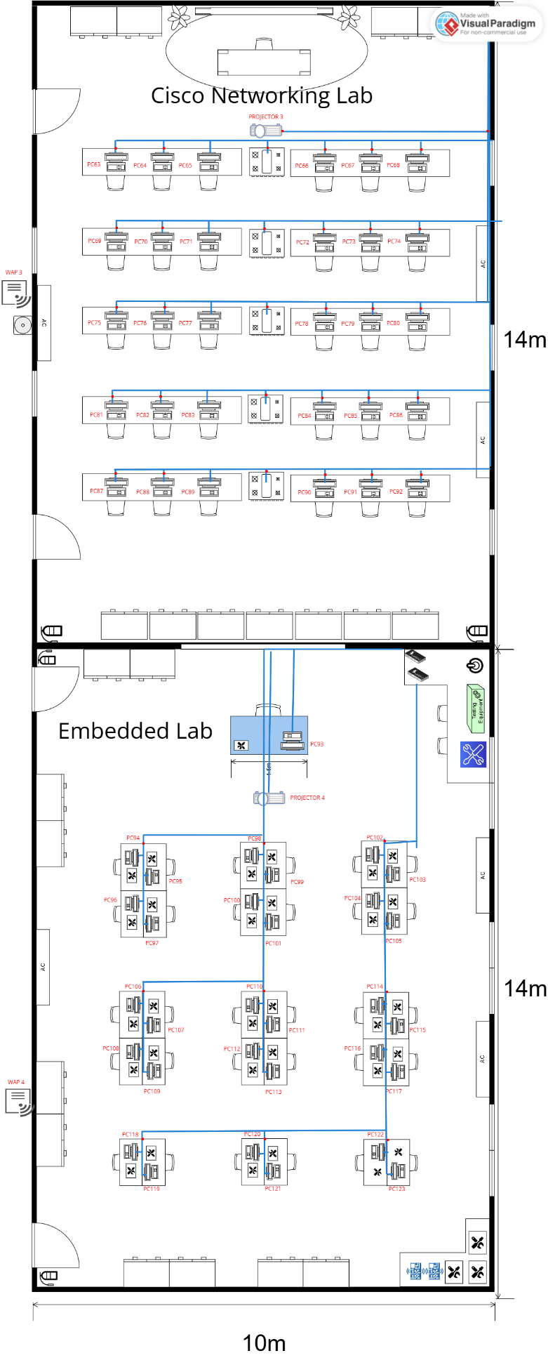
Figure 5.2.2 Cisco Networking Lab and Embeded Lab with label
First Floor:
- Hybrid Classroom
Device | IP Address
PC124 | 192.232.0.1
PC125 | 192.232.0.2
PC126 | 192.232.0.3
PC127 | 192.232.0.4
PC128 | 192.232.0.5
PC129 | 192.232.0.6
PC130 | 192.232.0.7
PC131 | 192.232.0.8
PC132 | 192.232.0.9
PC133 | 192.232.0.10
PC134 | 192.232.0.11
PC135 | 192.232.0.12
PC136 | 192.232.0.13
PC137 | 192.232.0.14
PC138 | 192.232.0.15
PC139 | 192.232.0.16
PC140 | 192.232.0.17
PC141 | 192.232.0.18
PC142 | 192.232.0.19
PC143 | 192.232.0.20
PC144 | 192.232.0.21
PC145 | 192.232.0.22
PC146 | 192.232.0.23
PC147 | 192.232.0.24
PC148 | 192.232.0.25
PC149 | 192.232.0.26
PC150 | 192.232.0.27
PC151 | 192.232.0.28
PC152 | 192.232.0.29
PC153 | 192.232.0.30
PC154 | 192.232.0.31
Projector 5 | 192.232.0.32
WAP 6 | 192.232.0.33

- Student Lounge
Device | IP Address
WAP 7 | 192.240.0.1

- Video Conferencing Room
Device | IP Address
IoT 1 | 192.248.0.1
WAP 8 | 192.248.0.2

- Staff Office
Device | IP Address
PC155 | 192.164.0.1
PC156 | 192.164.0.2
PC157 | 192.164.0.3
PC158 | 192.164.0.4
PC159 | 192.164.0.5
PC160 | 192.164.0.6
PC161 | 192.164.0.7
PC162 | 192.164.0.8
PC163 | 192.164.0.9
PC164 | 192.164.0.10
WAP 9 | 192.164.0.11

- Server Room
Device | IP Address
Router 1 | 192.164.0.12
Router 2 | 192.164.0.13
Router 3 | 192.164.0.14
Router 4 | 192.164.0.15
Server 1 | 192.164.0.16
Server 2 | 192.164.0.17
Server 3 | 192.164.0.18
Server 4 | 192.164.0.19
WAP 10 | 192.164.0.20

First floor with label:
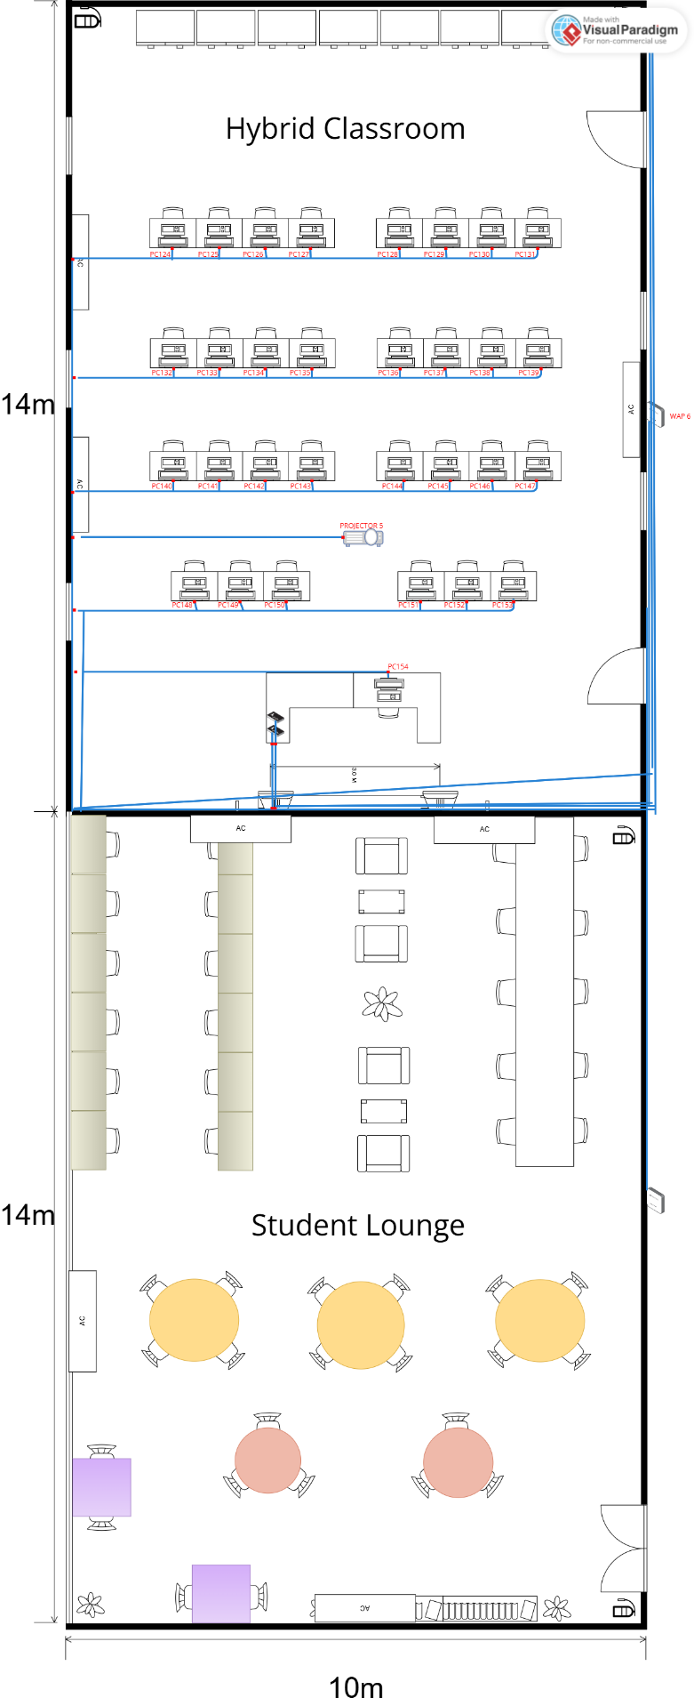
Figure 5.2.3 Hybrid Classroom and Student Lounge with label
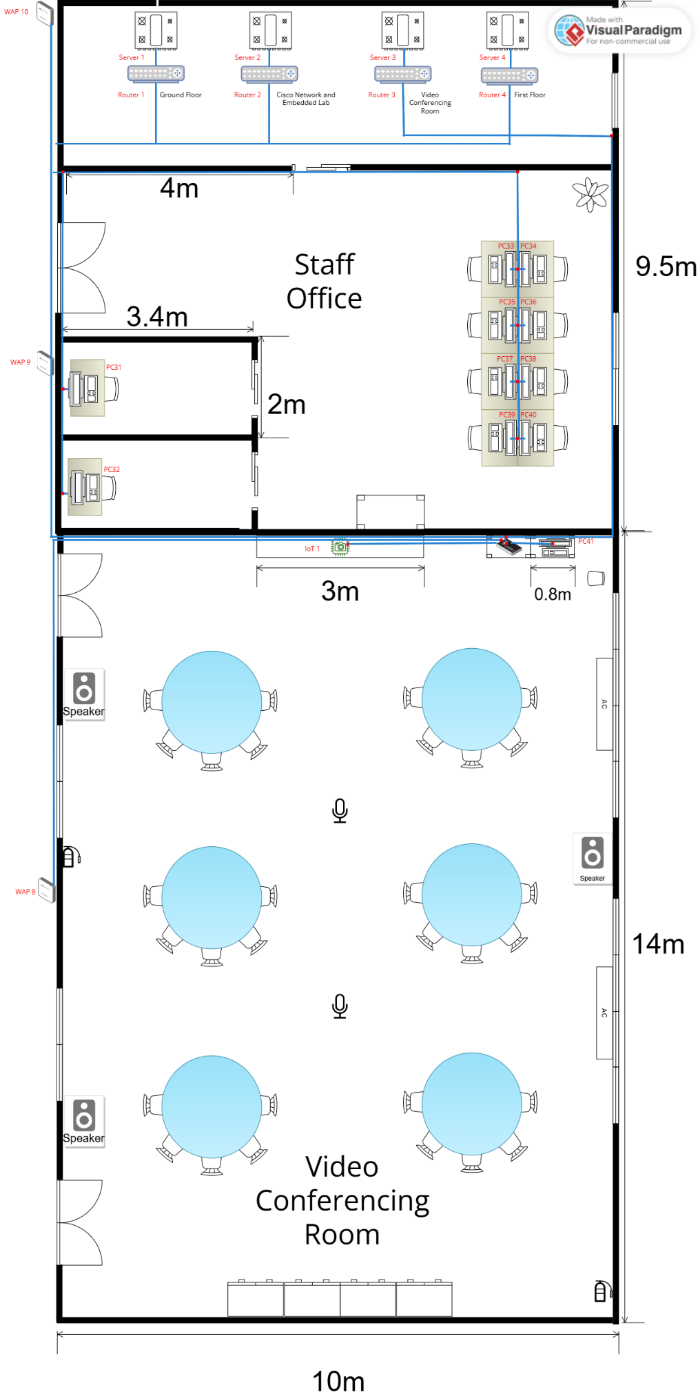
Figure 5.2.4 Server Room, Staff Office and Video Conferencing Room with label

Meeting Minutes #9
DATE/TIME |  | 22 Jan 2025 8pm
LOCATION |  | Google Meeting
AGENDA |  | - Discuss about all the task from task 5  - Discuss about the network division  - Complete task 5 together.
Meeting MC |  | Chau Ying Jia
ATTENDANCE
NAME |  | TIME | REASON FOR ABSENCE
Poh Lok Yee |  | 2000 | -
Woo Cheng Shuan |  | 2000 | -
Chau Ying Jia |  | 2000 | -
Sabrina Heng Wei Qi |  | 2000 | -
MINUTES
NO. | ITEM DISCUSSED | IDEAS/SUGGESTIONS AND PERSON GIVING IT | PERSON IN CHARGE
1 | Discussion for task 5 | Chau Ying Jia brief us the information and rubrics in task 5  All members read and understand requirements from task 5. | Chau Ying Jia
2 | Suggestion for network division | All members suggest their prefer subnetwork division and decide the one best suits our design | All members
3 | IP Addressing Scheme Overview | All members examine how IP addresses are currently assigned to each work area. | All members
4 | Task Distribution | Ying Jia distributed the tasks for all members. | All members
5 | Proceed Tasks 5 together | All members work on Words together to complete task 5. | All members
6 | Meeting Ended | Meeting ended after all discussions have done at 2300 | All members

